**FACTORY MONITORING AND ALERT SYSTEM**

|  |  |
| --- | --- |
| **Dr. Surajit Mandal**  Associate Professor in ECE  B P Poddar Institute of Management and Technology, Kolkata | **Dr. Ivy Majumdar**  Associate Professor and HOD in ECE  B P Poddar Institute of Management and Technology, Kolkata |
| **Agrika Gupta**  UG Student in ECE  B P Poddar Institute of Management and Technology, Kolkata | **Arko Sen**  UG Student in ECE  B P Poddar Institute of Management and Technology, Kolkata |
| **Ankit Banerjee**  UG Student in ECE  B P Poddar Institute of Management and  Technology, Kolkata | |

111

***Abstract –*** The basic idea of our project is to make a Monitoring and Alert System using Embedded System and IOT. Our project deals with various kinds of sensors (like temperature sensor, gas sensors, etc.) and other peripherals along with an Arduino UNO Microcontroller and Wi-Fi module. Here all these sensors will collect data from the surrounding, send it to the Arduino which will further send it to a website and will also send an alert if any sort of unwanted conditions are observed. Monitoring all the sensor data remotely with the help of Arduino UNO via Internet of Things is the main purpose of our project. We believe that this will provide the users a simple, reliable and speedy way to monitor a factory remotely and warn the people in case of any emergency.

***Keywords:*** Embedded System, Internet of Things, Arduino UNO, Temperature Sensor, Gas Sensor, Ultrasonic Sensor.

***I. INTRODUCTION***

India is aiming to become an industrial powerhouse with innovative mindset and also with government schemes and reforms. But various tragedies like catching fire, leakage of gases etc. with desperate and vulnerable workers who are often paying the price. Industrial accidents kill hundreds of people and permanently disable thousands every year. A federal minister told parliament in 2021 that [at least 6,500 workers had died](https://www.livemint.com/news/india/at-least-6-500-employees-died-on-duty-at-factories-mines-11616095209657.html) while working in factories, ports, mines and construction sites in five years. Labour activists, who had worked in the field for years, told the BBC that the figures could be higher as many incidents were not reported or recorded. [1]

Besides leakage of gases and catching of fires there are also boiler explosions that are equally hazardous to the lives of the workers. There are many causes for boiler explosions such as poor water treatment causing scaling and overheating of the plates, a stuck safety valve, or even a furnace explosion that in turn, if severe enough, can cause a boiler explosion. Poor operator training resulting in neglect or other mishandling of the boiler has been a frequent cause of explosions since the beginning of the industrial revolution. In the late 19th and early 20th century, the inspection records of various sources in the U.S., UK, and Europe showed that the most frequent cause of boiler explosions was weakening of boilers through simple rusting. [2]

Here in this paper, we present a factory monitoring and alert system. It will monitor all the physical parameters of the environment and will alert when necessary. We have designed this system with an aim to reduce the number of factory accidents. This paper also focuses on the IOT application in the new generation of environmental information and provides a new paradigm for environmental monitoring in future.

***II. METHODOLOGY***

The application for this project is in the areas where sudden high temperatures, slight modification to hazardous gases, and fluctuation of pressure can be have detrimental effects on the production efficiency and human life as a whole. The temperature sensor will take up the challenge of monitoring the current temperature of the place. We can set a threshold, crossing which the alarm will be triggered.

In addition to this, the pressure sensor will come into play where there is requirement for crucial monitoring of pressure like in cylinders or such places. It will routinely monitor the pressure changes and generate alert messages accordingly. The gas sensor will detect the quantity of gases like CO2, CH4, CO, LPG, etc. in the vicinity. Any fluctuation in these can cause detrimental effects on the human health and safety of the institution at large. Hence, it is essential to monitor this parameter.

Lastly, coming very close to the edge of the high places like boundary-less rooftops or near rotating blades have been responsible for causing lethal accidents. To prevent this, the ultrasonic sensor will be placed to measure the distance between the individuals and the danger-prone areas. The sensor works on the principle of echo. It will send a PWM signal, through the trig pin, and as soon as it hits an object it will return to the echo pin and measure the time taken. Taking speed of 340 m/s (as of sound) and the noted time we can calculate the distance easily. As the safe distance decreases, the alarm will be triggered so that the individuals are aware of their surroundings, hence saving their lives. All these parameters will be continuously send to the Arduino and it will establish a serial communication with the Node MCU which will send the data to the website.

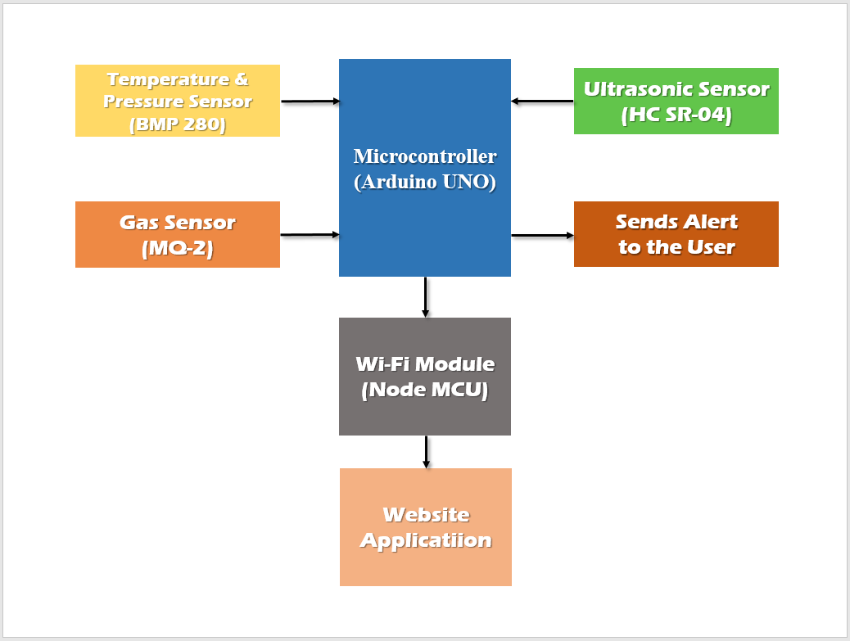

***Figure 1: Block Diagram of the Proposed System***

***A. Hardware***

*1. Arduino UNO Microcontroller*

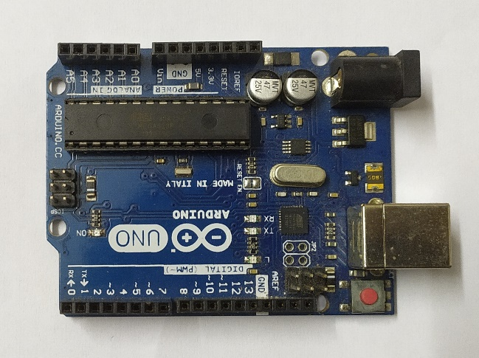

***Figure 2: Arduino UNO***

Arduino UNO is a microcontroller Board which is based on the AVR 8 bit ATmega328P microcontroller. It consists of 14 digital input/output pins that are used to connect with external electronic circuit, out of which 6 pins can be used as PWM output and 6 analog inputs. It allows the users to sense the external electronic devices in the real world. We have to simply connect it to a computer with a USB cable so that it gets started and transfer the code to the controller using IDE software, which has been developed to program the Arduino. AC to DC adapter or battery can also be used to power the board, apart from the USB. This board has such a simple programming interface that it does not require any external programmer. Due to the presence of 32Kb flash memory, the user’s code can be saved and it can also be modified according to the requirement of the user.

*2. Wi-Fi Module (Node MCU)*

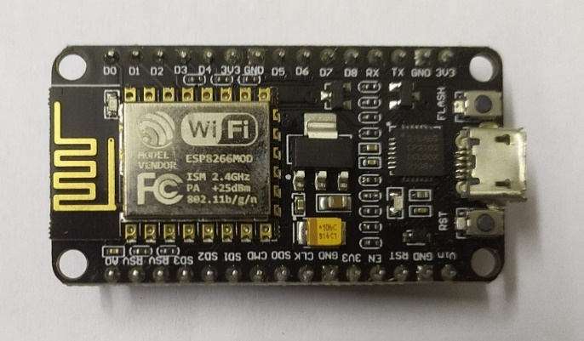

***Figure 3: Node MCU***

The Node MCU (ESP8266) used in this paper is more advanced than ESP826-01 which is mentioned in the paper “Real Time Health Monitoring System Using Arduino with Cloud Technology” [3]. ESP8266 integrates a Tensilica L106 32-bit RISC processor, which acquires extra-low power consumption and can achieve a maximum clock speed of 160 MHz Node MCU is an open source platform based on ESP8266 which connects objects and transfers data using Wi-Fi protocol. In addition, it provides some of the most important features of microcontrollers such as GPIO, PWM, ADC, and etc. The power-saving architecture facilitates three modes of operation: active mode, sleep mode and deep sleep mode. It has an internal antenna and it contains 13 GPIO pins, 10 PWM channels, I2C, SPI, ADC, UART, and 1-Wire.

*3. Temperature and Pressure Sensor (BMP 280)*

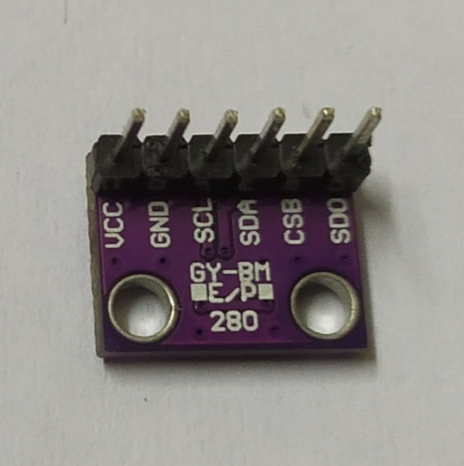

***Figure 4: BMP 280***

In the paper ***“IOT Based Weather Monitoring System Using Arduino-Uno”*** [4] mentioned below, BMP180 sensor was used to only monitor the pressure but here BMP280 sensor is used which is an absolute barometric temperature and pressure sensor, which is especially applicable for mobile applications. It provides features like it has small dimensions and consumes less power which in turn it is allowed to implement in battery-powered devices such as mobile phones, GPS modules or watches. The BMP280 is based on Bosch’s proven piezo-resistive pressure sensor technology which features high accuracy and linearity as well as it has long-term stability and high EMC robustness. Just like other sensors, these sensors are also pre-calibrated. So, after power-up they start measuring temperature, pressure and humidity immediately. No additional components are required for calibration or operation.

*4. Gas Sensor (MQ-2)*

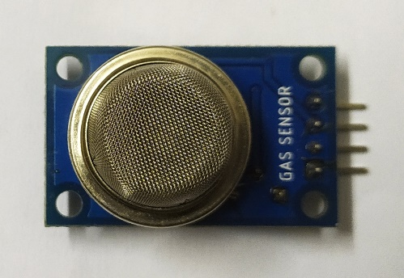

***Figure 5: MQ-2***

**MQ2 Gas sensor** is a Metal Oxide Semiconductor (MOS) type Gas Sensor which mainly detect gases like **Methane, Butane, LPG, Smoke,** etc. When the Gas comes in to contact, the gas detection is based on the change of resistance of the sensing material, so it is sometimes called Chemiresistors. **MQ2 Gas sensor module** works on 5V DC and uses around 800mW.Concentration of gas is measured using a voltage divider network which is present inside the sensor. It can detect gases in the range of 200 to 10000 ppm.

*5. Ultrasonic Sensor (HC SR04)*

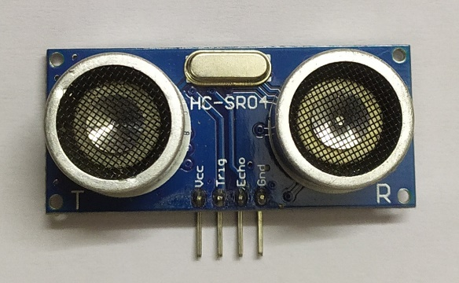

***Figure 6: HC SR04***

This is an ultrasonic distance sensor. This economical sensor provides non-contact measurement functionality within the range 2cm to 400 cm and its ranging accuracy can reach up to 3mm. The HC-SR04 module consists of an ultrasonic transmitter, a receiver and a control circuit. There are four pins in this module: VCC (Power), Trig (Trigger), Echo (Receive), and GND (Ground). It consists of two ultrasonic transducers. One of them acts as a transmitter which converts the electric signal into 40 KHz ultrasonic signal and the other one acts as a receiver and listens to the transmitted impulses. This sensor has additional control circuitry which prevents inconsistent bouncy data depending upon the application.

*6. Piezo Buzzer*

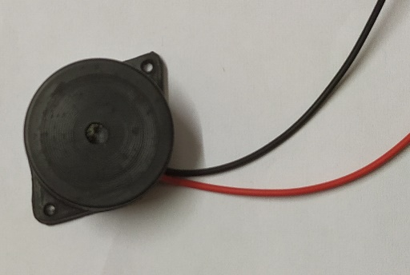

***Figure 7: Piezo Buzzer***

A piezo buzzer in simple terms, is a type of electronic device that produces a sound or a noise. It has a simple construction, with lightweight features and is typically a low-cost product. At the same time, depending on the piezo ceramic buzzer specifications, it can be constructed in a wide range of sizes which work across varying frequencies to produce different kinds of sound outputs. Here we are using it to produce any kind of alert.

***Figure 8: Circuit Diagram of the System***

***B. Software***

The heart or the central part of the project is the microcontroller, which is the Arduino UNO. The code has been written in the Arduino IDE. Header files has been used for establishing the Wi-Fi connection and also for the serial communication between the Arduino and Node MCU [6]. The BMP 280 Temperature and Pressure sensor collects the data through the SDA pin and the Arduino receives it through the analog pins using the *analogRead()* function [5]. The Ultrasonic sensor produces a PWM signal using the *digitalWrite()* function of the Arduino by giving a particular Time Period and uses the SONAR mechanism to calculate the distance of the obstacle. The MQ-2 Gas Sensor collects the data and uses the analog pin to send the data to Arduino. For all the parameters, individual threshold values has been defined and if any value crosses the threshold, then an alarm will be triggered to warn the admin.

After collecting all the data from the sensors, the website has been designed using technologies like HTML, CSS and JavaScript. Four segments have been made for in the webpage for displaying the four parameters and accordingly four functions has been designed to fetch the values from the sensors and send them to the website. The HTML is used to create the basic skeleton of the webpage. The CSS is used to beautify the webpage with various colors and designs to make it look more attractive. The JavaScript is used to send all 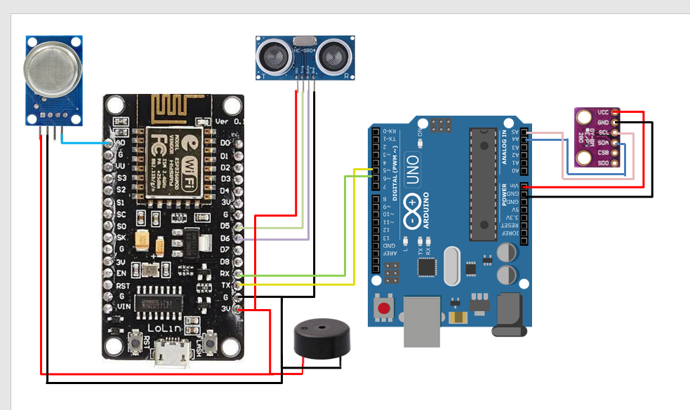the data from the sensors to the webpage using the Wi-Fi Module. The code has been written such that after every 5 seconds the page will reload and will help us to continuously monitor all the values without even manually reloading or refreshing the page.

***III. EXPERIMENTAL RESULTS***

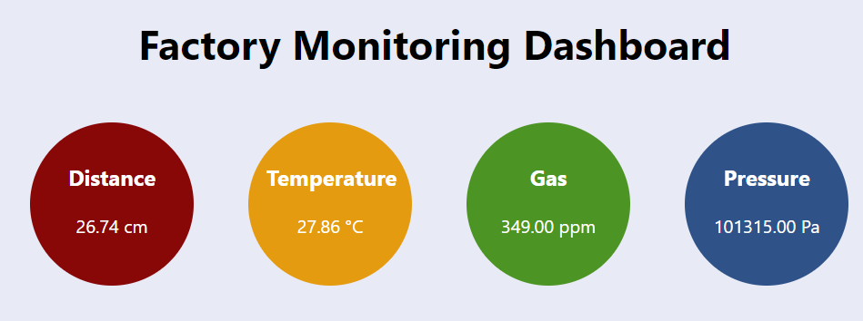After making all the hardware connections and uploading the code, the sensors started fetching all the data from the environment and those are being successfully sent to the website via the Wi-Fi module. The values are being automatically updated in the website after every 5 seconds.

***Figure 9: Snapshot of the Website displaying the parameters***

In the above figure, we can observe that four values have been sent to the website from sensors. Firstly, the distance is measured from an obstacle placed in front of the ultrasonic sensor and it is found out to be 26.74 cm. The distance decreases or increases as one moves the obstacle close to or far from the sensor respectively. Secondly, the temperature of the surrounding was measured using the temperature sensor and the environmental temperature was measured to be 27.8 oC. Thirdly, the gas sensor was used to measure the concentration of any combustible gas (here CO2) present in the surrounding, which was measured to be 349 ppm (parts per million). The values could alter depending on the surrounding situations. Like, during any combustible situation, the value could range from 600-800 ppm or even more. The maximum range it can reach is 1023. Lastly, the pressure sensor was used to measure the atmospheric pressure which was close to 1 atm (or 105 Pa).

For each values being measured, experimental thresholds have been set so that if any value measured is more than the threshold, then a signal will be sent to the Arduino and it will in turn trigger the buzzer and the buzzer will blow thus alarming the staffs so that necessary actions could be taken immediately without harming much.

***IV. ADVANTAGES***

* This system is a smart way to monitor a place and that is too remotely.
* It is a totally automated system and does not require any human intervention.
* It is a cost effective system, as the sensors here used are easily available in the market at a very cheap price.
* It is a flexible system and the user can add more sensors for better monitoring of a place.
* It is a very efficient system and the accuracy for this system is very high.

***V. LIMITATIONS***

* The sensors used here cannot be used for large scale projects. For that other sensors need to be considered.
* These sensors are extremely sensitive. So proper voltage regulation must be there else the sensors could damage.

***VI. CONCLUSION***

As a conclusion, a prototype of Factory Monitoring and Alert System has been successfully developed. In this system, the physical parameters are collected using various sensors and these data are send to a webpage using Wi-Fi Module and are displayed over there. This system can warn the workers at the factory during some emergency like sudden increase in the temperature or pressure of the furnace. If these changes can be noticed at a very early stage then immediate actions could be taken to prevent a major accident, thus saving the life of many workers.

***VII. FUTURE SCOPE***

The Future Scope of the project is to incorporate more sensors into the system, like chemical sensors, radioactive sensors, etc., for better monitoring of the surrounding and also to advance the alerting system. For now, we are just firing a buzzer but later we can use a GSM Module to send alert to the user to their mobile phones or we can also send them a mail.

***VIII. REFERENCES***

***[1]*** [***https://www.bbc.com/news/world-asia-india-62631699***](https://www.bbc.com/news/world-asia-india-62631699)***.***

***[2] https://en.wikipedia.org/wiki/Boiler_explosion.***

***[3] R. Anandh and G. Indirani , “Real Time Health Monitoring System Using Arduino with Cloud Technology” Asian Journal of Computer Science and Technology ISSN: 2249-0701 Vol.7 No.S1, 2018, pp. 29-32.***

***[4] Hashmi, Shifa and Pawar, Jayshree and Manegopale, Parmeshwar and Wagh, Kavita, IOT Based Weather Monitoring System Using Arduino-Uno (April 8, 2022). Available at SSRN:***[***https://ssrn.com/abstract=4113699***](https://ssrn.com/abstract=4113699)***or***[***http://dx.doi.org/10.2139/ssrn.4113699***](https://dx.doi.org/10.2139/ssrn.4113699)

***[5] Akinwole, Oyewole & O.S, Adeoye. (2020). Designing Embedded Systems with Arduino Microcontrollers: A Way Forward for Technological Advancement in Nigeria. International Journal of Electrical and Electronics Engineering. 7. 1-5. 10.14445/23488379/IJEEE-V7I3P101.***

***[6] Sneha, Talapala & Balasubramanian, Ssneha & R, Vaishali & J, Jay & Ap, Beulah & Suseelan, Angel. (2021). Home Security System for the Hearing Impaired. 1-5. 10.1109/ICCCSP52374.2021.9465502.***